 TAGORE ENGINEERING COLLEGE 

# SB8055 – BLOCK CHAIN DEVELOPMENT

|  |  |
| --- | --- |
| DATE | 30 OCTOBER 2023 |
| TEAM ID | NM2023TMID01005 |
| PROJECT NAME | Food tracking system |

|  |  |
| --- | --- |
| TEAM LEADER | G.Chandru |
| TEAM MEMBER 1 | A.Kalidass |
| TEAM MEMBER 2 | S.Krishna |
| TEAM MEMBER 3 | R.Sathishkumar |

# 

# Nutrition Tracker: A significant Step towards Optimal Wellness

# INTRODUCTION

* 1. Project Overview
  2. Purpose

# LITERATURE SURVEY

* 1. Existing problem
  2. References
  3. Problem Statement Definition

# IDEATION & PROPOSED SOLUTION

* 1. Empathy Map Canvas
  2. Ideation & Brainstorming

# REQUIREMENT ANALYSIS

* 1. Functional requirement
  2. Non-Functional requirements

# PROJECT DESIGN

* 1. Data Flow Diagrams & User Stories
  2. Solution Architecture

# PROJECT PLANNING & SCHEDULING

* 1. Technical Architecture
  2. Sprint Planning & Estimation
  3. Sprint Delivery Schedule

# CODING & SOLUTIONING (Explain the features added in the project along with code)

* 1. Feature 1
  2. Feature 2
  3. Database Schema (if Applicable)

# PERFORMANCE TESTING

* 1. Performace Metrics

# RESULTS

* 1. Output Screenshots

1. **ADVANTAGES & DISADVANTAGES**
2. **CONCLUSION**
3. **FUTURE SCOPE**
4. **APPENDIX**

Source Code

GitHub & Project Demo Link

**PROBLEM STATEMENT:**

Fooditems like fruits and vegetables generally do not have any expiry date mentioned so it becomes important to understand the origin of these food items and know the date when was

it sent to the distributor from the farmer and so on.

Design a smart contract using the ethereum blockchain where you should be able to authenticate the food item and consume that without any worry

# 1.INTRODUCTION:

# In a world where fruits and vegetables lack clear expiry dates, ensuring food safety and quality is essential. We propose a Ethereum blockchain-based smart contract solution to authenticate food items, trace their origins, and monitor their journey from farmer to distributor. This innovative approach empowers consumers to enjoy their produce with confidence, as they can access transparent and immutable data about each item, eliminating worries and ensuring a safer and more reliable food consumption experience.

* 1. **Project Overview:**

The primary goal of this project is to develop a smart contract system on the Ethereum blockchain that enables the authentication and traceability of food items, particularly fruits and vegetables. This system will provide consumers with the ability to verify the origin and journey of these food items, ensuring their quality and safety.

* 1. **Purpose**

Thepurpose of this project is to leverage blockchain technology, specifically Ethereum smart contracts, to address the challenges associated with verifying the authenticity and traceability of food items, such as fruits and vegetables. The project aims to achieve the following key objectives:

**Enhanced Food Safety**: Ensure that consumers can confidently consume food items by providing them with transparent and reliable information about the origin, journey, and quality of the products.

**Reduce Food Fraud**: Mitigate the risks associated with counterfeit or misrepresented food items in the market by creating a system that verifies the authenticity of products.

**Promote Transparency**: Create a decentralized, immutable ledger that tracks the history of each food item, allowing all stakeholders to access and validate information.

**Minimize Food Waste**: Enable consumers to make informed decisions about consuming food items before they spoil, thereby reducing food waste and promoting sustainability.

**Empower Stakeholders**: Equip farmers, distributors, retailers, and consumers with a tool to participate actively in maintaining the integrity of the food supply chain.

**Pilot Innovation**: Pilot a real-world solution that has the potential to revolutionize the way consumers interact with food products and the way the food industry manages its supply chains.

**2. LITERATURE SURVEY:**

**2.1 Existing Problem:**

Existingproblems in the food industry include a lack of transparency, counterfeit products, and food safety risks. Consumers often distrust the authenticity and quality of their purchases due to the absence of reliable traceability systems. This leads to premature food waste and challenges in maintaining data integrity throughout complex supply chains. Additionally, regulatory compliance and consumer empowerment are ongoing issues. These problems can be mitigated through the implementation of blockchain technology, as it ensures transparency, authenticity, and consumer confidence in food products.

|  |  |  |  |  |
| --- | --- | --- | --- | --- |
| **Year** | **Author** | **Title** | **Approach** | **Result** |
|  |  |  | The paper introduces the concept of traceability and its significance in the food industry. | Incorporating this |
|  |  |  | literature can be |
| 2006 | E. Mardle and D.  C. Lambkin | Traceability: a management tool for food safety and quality | beneficial for  building a foundational understanding of traceability's importance in |
|  |  |  | food safety and |
|  |  |  | quality. |
|  |  |  | A significant | The result of |
|  |  |  | portion of the | following the |
| 2014 | Tammy Gangloff, Steven Gangloff, and September Ferguson. | The Ultimate Dehydrator Cookbook" | book is dedicated  to a wide variety of recipes. It covers dehydrated fruits, vegetables, | guidance in this  book is the ability to make the most of food dehydration, |
|  |  |  | herbs, spices, and | making your food |
|  |  |  | even meals like | supply more |
|  |  |  | jerky. | versatile and |
|  |  |  |  | reducing food |
|  |  |  |  | waste |
|  | Simon Ellinor | Blockchain | His work delves into the benefits and challenges of using blockchain to ensure transparency and traceability in the origin of food products. | The result includes |
|  |  | Technology in | that blockchain |
|  |  | Food Supply | technology used in |
| 2016 |  | Chains | traceability for |
|  |  |  | food products and |
|  |  |  | in order to check |
|  |  |  | the freshness. |
|  |  |  | The paper introduces the concept of blockchain technology and its applications in supply chain and logistics. | Incorporating this |
|  |  |  | literature into |
|  |  |  | your research can |
|  |  | Blockchain in | significantly |
| 2019 | Dmitry Ivanov and | supply chain and | strengthen your |
|  | Abhijit Das | logistics: | understanding of |
|  |  | Challenges and | how blockchain |
|  |  | opportunities | technology can |
|  |  |  | address challenges |
|  |  |  | and improve |
|  |  |  | traceability in the |
|  |  |  | food supply chain. |
|  |  |  |  |  |

**2.2 References:**

* Mora, C., Nigro, L., Guarino, A. and Galle, A., 2018. "Blockchain for the Internet of Things: A Systematic Literature Review." In 2018 IEEE/RSJ International Conference on Intelligent Robots and Systems (IROS), pp. 5128-5135**.**
* Miao, M., Zeng, D., Li, S., Mao, J. and Wang, P., 2017. "A Blockchain-Based Cloud Storage System." In 2017 IEEE International Congress on Big Data (BigData Congress),

pp. 13-20.

* Food and Agriculture Organization of the United Nations (FAO). (2018). "Blockchain Application in the Food Supply Chain: A Cultural Approach." Retrieved from [FAO](http://www.fao.org/3/i9646en/I9646EN.pdf).
* IBM. (2017). "IBM Food Trust™: Making the food supply chain safer, more efficient and sustainable." Retrieved from [IBM Food Trust](https://www.ibm.com/blockchain/solutions/food-trust).
* Walmart. (2018). "Blockchain Enables Food Traceability." Retrieved from [Walmart](https://www.walmart.com/traceability).

**2.3 Problem Statement Definition:**

The current state of the food industry presents several critical challenges that undermine consumer confidence and safety. One of the primary issues is the lack of transparency within the food supply chain. Consumers often have no access to essential information about the origin, journey, and quality of the food items they purchase, which leaves them in a state of uncertainty and doubt. This opacity in the supply chain also provides fertile ground for counterfeit and misrepresented food products to enter the market, endangering public health and eroding trust in the industry.

Furthermore, the absence of a robust system for food authentication and traceability exposes consumers to potential food safety risks, as they cannot readily ascertain the freshness and authenticity of their purchases. This problem contributes to food waste, as consumers often discard items prematurely due to doubts about their quality.

Complex supply chains, inefficient record-keeping, and difficulties in regulatory compliance exacerbate these challenges, making it challenging for the industry to maintain data integrity and accountability. Consequently, consumers are left without the necessary tools to validate the authenticity and quality of the food they consume, exacerbating the problem of distrust.

In summary, the problem at hand is the deficiency of transparency, authenticity, and trust in the food supply chain, which not only threatens consumer safety and satisfaction but also cont

**3.IDEATION & PROPOSED SOLUTION**

* 1. **Empathy Map Canvas**

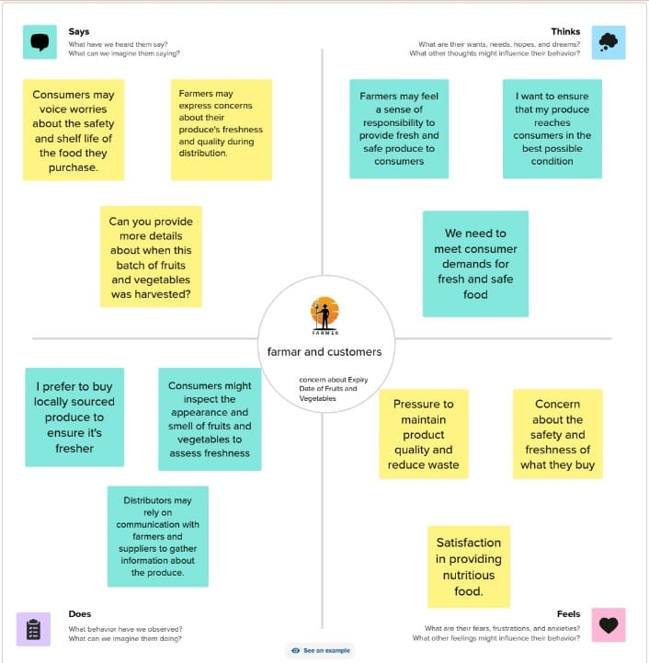

**3.2Ideation & Brainstorming**

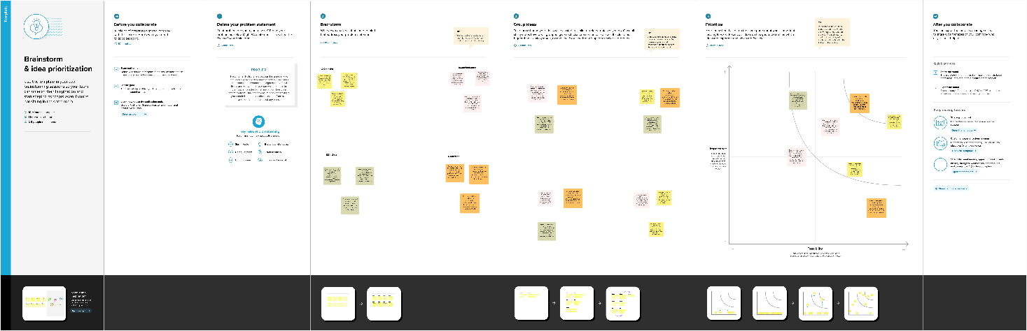

**Problem Statement:**

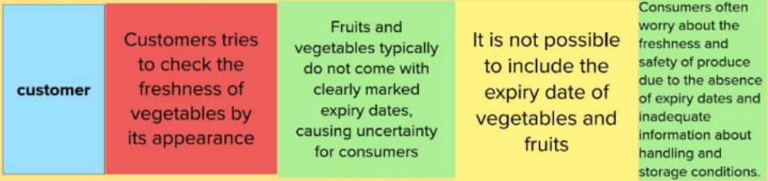

|  |  |  |  |  |  |  |  |  |  |
| --- | --- | --- | --- | --- | --- | --- | --- | --- | --- |
| **Problem statement** | **I am** | **I am trying to** | | **but** | | **because** | | **Which makes me feel** | |
| **PS-1** | Customer | Customers tries to check the freshness of vegetables by its appearance | | Fruits and vegetables typically do not come with clearly marked expiry dates, causing uncertainty for consumers | | It is not possible to include the expiry date of vegetables and fruits | | Consumers often worry about the freshness and safety of produce due to the absence of expiry dates and inadequate information about handling and storage conditions. | |
| **PS-2** | Salesperson | | Salesperson tries to sale the fruits and vegetables | | Customers wants to check the freshness of fruits and vegetable. | | Fruits and vegetables are not able to pack in preserved cover. | | So it reduces the revenue and confidence in related to freshness. |

**4.REQUIREMENT ANALYSIS**

**4.1Functional Requirements:**

Functional requirements outline the specific functions and capabilities the blockchain-based food tracking system

|  |  |  |
| --- | --- | --- |
| **FR NO** | **Functional requirements** | **Sub requirement** |
| FR-1 | User Registration and Authentication | Users, including farmers, distributors, retailers, and consumers, should be able to register and authenticate their identities to access the system. |
| FR-2 | Food Item Registration | Stakeholders (e.g., farmers, distributors) must have the capability to register food items, providing details like product type, quantity, and source. |
| FR-3 | Unique Identifiers | Assign a unique identifier (e.g., QR code) to each food item for easy traceability and verification. |
| FR-4 | Data Input and Verification | Enable authorized users to update and verify data at various stages of the food supply chain to ensure data accuracy and authenticity. |
| FR-5 | Consumer Interface | Develop a user-friendly interface (web or mobile app) for consumers to access food item information by scanning unique identifiers or searching for product details. |
| FR-6 | Blockchain Integration | Create and deploy smart contracts on the Ethereum blockchain for secure and immutable data storage. |
| FR-7 | Traceability and History | Allow users to trace the history of each food item, including its origin, processing, and transportation details. |

**4.2 Non-Functional Requirements:**

Non-functional requirements define the quality attributes, constraints, and criteria that the system must meet.

|  |  |  |
| --- | --- | --- |
| **NFR NO** | **Non-Functional requirements** | **Subrequirement** |
| NFR-1 | Security | Data stored on the blockchain should be highly secure, with encryption and access controls to protect sensitive information. It should also comply with data privacy regulations (e.g., GDPR). |
| NFR-2 | Scalability | The system should be capable of handling a growing volume of food items, users, and data as the user base expands without compromising performance. |
| NFR-3 | Usability | The user interfaces, both for consumers and stakeholders, should be user-friendly and accessible on various devices and platforms, ensuring a smooth user experience. |
| NFR-4 | Performance | The system must perform efficiently, with minimal latency, to provide real-time or near-real-time access to food item information for consumers and stakeholders. |
| NFR-5 | Reliability | The system should have a high level of availability to ensure stakeholders can access it when needed, with minimal downtime. It should also provide data redundancy and backup capabilities. |
| NFR-6 | Compliance | The system should comply with relevant food safety and traceability regulations and standards to assure stakeholders of its adherence to industry requirement. |
| NFR-7 | Interoperability | The system should be able to integrate with other existing databases, applications, and systems used in the food industry, allowing for a seamless exchange of information and data. |

**5.PROJECT DESIGN**

**5.1 Data Flow Diagrams & User Stories**

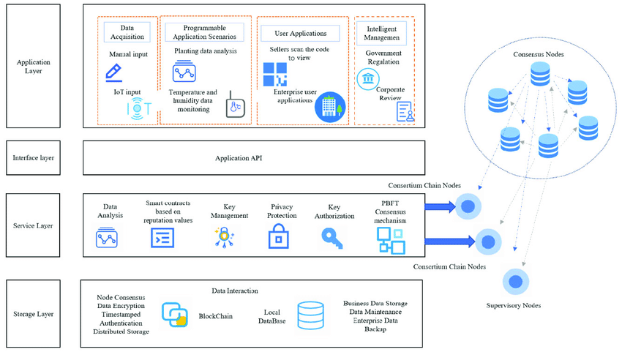

**User Stories:**

|  |  |  |  |  |  |  |  |  |
| --- | --- | --- | --- | --- | --- | --- | --- | --- |
| **User Type** | **Functional**  **Requirement**  **(Epic)** | **User Story**  **Number** | **User Story / Task** | **Acceptance Criteria** | **Priority** | | | **Name** |
| Farmer | User Registration | USN-1 | As a farmer, I want to register my harvested produce into the | 1)The farmer can access the system and find a clear option to register the harvested food. | High | | | Chandru |
| Distributor | Updating information | USN-2 | As a distributor, I want to update information about the transportation and storage conditions of the food items I receive, maintaining the traceability and quality records. | 1)The distributor can log in to the system using their credentials.  2)After logging in, there should be an option to update information about the transportation and storage conditions of the food items received. | | High | Sathish | |
| Retailer | Verification | USN-3 | As a retailer, I want to verify the source and journey of the food items I stock, enabling me to offer accurate product information to consumers. | The retailer should be able to offer consumers a user-friendly interface, such as a mobile app, to access food item information. | | High | Krishna | |
| Customer | System Integrity | USN-4 | As a consumer, I want to scan a QR code on a food item and instantly access its origin, quality | The consumer should be able to access a user-friendly app provided by the retailer or a dedicated food traceability | | High | Kalidass | |

**6.PROJECT PLANNING AND ESTIMATION:**

**6.1TECHNICAL ARCHITECTURE**

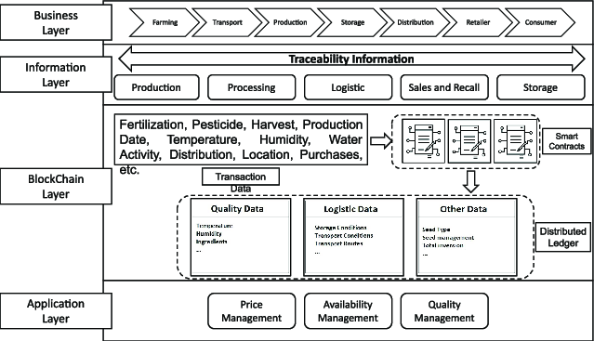

**6.2SPRINT PLANNING AND ESTIMATION**

**SPRINT PLANNING**

|  |  |  |
| --- | --- | --- |
| **TITLE** | **DESCRIPTION** | **DATE** |
| Specify the business problem | The business problem is the lack of transparency and traceability in the food supply chain for fruits and vegetables, leading to reduced consumer confidence, food safety risks, and increased food waste. | October 9 2023 |
| Literature survey and information gathering | Gather information from academic databases, industry reports, government websites, blockchain associations, case studies, online forums, and experts to understand the challenges and solutions in blockchain-based food traceability. | October 10 2023 |
| Prepare empathy map | This creates feelings of anxiety, mistrust, and uncertainty, which drive their actions to actively seek information through scanning and verification, and potentially avoiding purchases altogether. | October 11 2023 |
| Ideation | Ideation includes developing a blockchain-based system with a user-friendly app for food traceability, integrating unique identifiers on food items, and enabling stakeholders to record and verify data. | October 11 2023 |
| Solution architecture | A decentralized blockchain-based system with Ethereum smart contracts for transparent data storage, a user-friendly mobile app for consumers, and integrated unique identifiers to authenticate and trace food items. | October 11 2023 |
| Business requirements | Establish transparency in the food supply chain by implementing blockchain technology, enabling stakeholders to record, verify, and access food item data, ensuring authenticity. | October 11 2023 |
| Data flow diagram | Illustrate the flow of information within the system, emphasizing how blockchain ensures data. | October 11 2023 |
| Technology architecture | Specify the technologies required, including blockchain platforms, programming languages, and database systems. | October 11 2023 |
| Project development | Develop a blockchain-based food traceability system using Ethereum. Phases: Smart contract creation, data input, user app development, testing, pilot, scalability. Ensure transparency, authenticity, and consumer confidence. | October 11 2023 |

**ESTIMATION**

|  |  |  |  |  |  |  |
| --- | --- | --- | --- | --- | --- | --- |
| **Sprint** | **Functional Requirements** | **User Story Number** | **User Story/Task** | **Story Points** | **Priority** | **Team members** |
| 1 | Registration | USN1 | I want to register my harvested produce and receive unique identifiers to ensure traceability and authenticity. | 5 | High | Team lead |
| 2 | Storage | USN2 | I need to record transportation and storage data for food items to maintain traceability. | 8 | High | Team mem 01 |
| 3 | Verification | USN3 | I want an easy-to-use app for verifying food item sources to enhance consumer confidence. | 3 | Medium | Team mem 02 |
| 4 | Security | USN4 | I want to scan food items for instant access to origin. | 5 | High | Team mem 03 |

**6.3. SPRINT DELIVERY SCHEDULE**

|  |  |  |  |  |  |  |
| --- | --- | --- | --- | --- | --- | --- |
| **Sprint** | **Total story points** | **duration** | **Sprint start date** | **Sprint end date** | **Story points completed(as on planned end date)** | **Sprint release date** |
| Sprint 1 | 20 | 3 days | Oct 9 | Oct 12 | 20 | Oct 12 |
| Sprint 2 | 20 | 3 days | Oct 13 | Oct 16 | 20 | Oct 16 |
| Sprint 3 | 20 | 3 days | Oct 17 | Oct 20 | 20 | Oct 20 |
| Sprint 4 | 20 | 3 days | Oct 21 | Oct 23 | 20 | Oct 23 |
| Sprint 5 | 20 | 3 days | Oct 24 | Oct 27 | 20 | Oct 27 |

**7.CODING AND SOLUTIONING:**

// SPDX-License-Identifier: MIT

pragma solidity ^0.8.0;

contract FoodTracking {

address public owner;

enum FoodStatus {

Unverified,

Verified,

Consumed

}

struct FoodItem {

string itemId;

string productName;

string origin;

uint256 sentTimestamp;

FoodStatus status;

}

mapping(string => FoodItem) public foodItems;

event FoodItemSent(

string indexed itemId,

string productName,

string origin,

uint256 sentTimestamp

);

event FoodItemVerified(string indexed itemId);

event FoodItemConsumed(string indexed itemId);

constructor() {

owner = msg.sender;

}

modifier onlyOwner() {

require(msg.sender == owner, "Only contract owner can call this");

_;

}

modifier onlyUnconsumed(string memory itemId) {

require(

foodItems[itemId].status == FoodStatus.Verified,

"Item is not verified or already consumed"

);

_;

}

function sendFoodItem(

string memory itemId,

string memory productName,

string memory origin

) external onlyOwner {

require(

bytes(foodItems[itemId].itemId).length == 0,

"Item already exists"

);

foodItems[itemId] = FoodItem({

itemId: itemId,

productName: productName,

origin: origin,

sentTimestamp: block.timestamp,

status: FoodStatus.Unverified

});

emit FoodItemSent(itemId, productName, origin, block.timestamp);

}

function verifyFoodItem(string memory itemId) external onlyOwner {

require(

bytes(foodItems[itemId].itemId).length > 0,

"Item does not exist"

);

require(

foodItems[itemId].status == FoodStatus.Unverified,

"Item is already verified or consumed"

);

foodItems[itemId].status = FoodStatus.Verified;

emit FoodItemVerified(itemId);

}

function consumeFoodItem(

string memory itemId

) external onlyUnconsumed(itemId) {

foodItems[itemId].status = FoodStatus.Consumed;

emit FoodItemConsumed(itemId);

}

function getFoodItemDetails(

string memory itemId

)

external

view

returns (string memory, string memory, uint256, FoodStatus)

{

FoodItem memory item = foodItems[itemId];

return (item.productName, item.origin, item.sentTimestamp, item.status);

}

}

**8.PERFORMANCE TESTING**

* 1. **PERFORMANCE METRICS**

|  |  |  |  |
| --- | --- | --- | --- |
| **S.No.** | **Parameter** | **Values** | **Screenshot** |
| 1. | Information gathering | Setup all the Prerequisite: | Install vs code:  WhatsApp Image 2023-10-29 at 8.52.23 PM  Install metamask  WhatsApp Image 2023-10-29 at 8.49.40 PM  Install node js |
|  |  |  | WhatsApp Image 2023-10-29 at 9.01.49 PM |

|  |  |  |  |
| --- | --- | --- | --- |
| 2. | Extract the zip files | Open to vs code | WhatsApp Image 2023-10-29 at 2.55.18 PM |
|  |  |  | WhatsApp Image 2023-10-29 at 2.55.26 PM |
| 3. | Remix Ide platform explorting | Deploy the smart contract code  Deploy and run the transaction. By selecting the  environment - inject the  MetaMask. | WhatsApp Image 2023-10-29 at 2.55.27 PM    WhatsApp Image 2023-10-29 at 2.55.28 PM    WhatsApp Image 2023-10-29 at 2.55.30 PM |
| 4. | Open file  explorer | Open the extracted file and  click on the folder.  Open src, and search for utiles.  Open cmd  enter  commands  1.npm  install  2.npm bootstrap  3. npm start |  |
| 5. | Local ip address | copy the address and open it to  chrome so you can see the front end of your project. |  |

**9.RESULTS:**

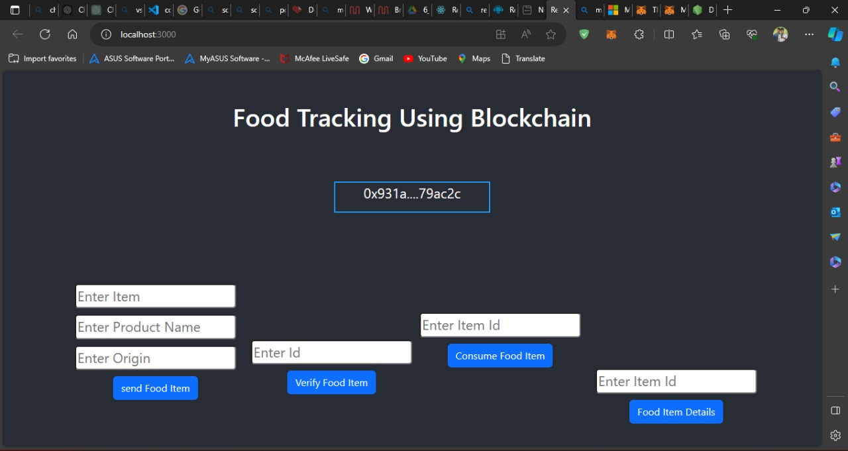

**10. ADVANTAGES AND DISADVANTAGES:**

**ADVANTAGES:**

* **Transparency**: Provides a transparent view of the food supply chain, fostering trust among stakeholders and consumers.
* **Data Integrity**: Ensures data accuracy and immutability, reducing the risk of fraud and errors.
* **Enhanced Consumer Confidence**: Empowers consumers to make informed food choices with access to authentic product information.
* **Food Safety**: Reduces the risk of consuming spoiled or contaminated food items, improving overall food safety.
* **Reduced Food Waste**: Minimizes food waste by enabling consumers to use items before they spoil.
* **Compliance**: Facilitates compliance with food safety and traceability regulations, reducing regulatory risks.
* **Traceability**: Allows for easy traceability of food items from farm to table, aiding in product recalls and quality control.
* **Efficiency**: Streamlines supply chain processes and data management, improving operational efficiency for businesses.

**Disadvantages:**

* **Implementation Costs**: Developing and implementing the system can be expensive, especially for small businesses.
* **Complexity**: The integration of blockchain technology and data management can be complex, requiring specialized expertise.
* **User Adoption**: Stakeholders may resist adopting new technologies, affecting the system's effectiveness.
* **Privacy Concerns**: Storing sensitive data on a public blockchain may raise privacy and security concerns.
* **Data Loss Risk**: If not properly backed up, data on the blockchain can be at risk of permanent loss.
* **Scalability Challenges**: Ensuring the system can handle a large volume of data and users can be challenging.
* **Regulatory Compliance**: Compliance with evolving regulations may require ongoing adjustments to the system.
* **User Errors**: Human errors in data entry or verification could lead to inaccuracies in the system.

**11.CONCLUSION:**

In conclusion, the development of a blockchain-based food traceability and authenticity system holds immense potential to address critical challenges within the food supply chain. By ensuring transparency, data integrity, and consumer empowerment, this solution can instill trust and confidence in food products. Despite potential disadvantages such as implementation costs and complexity, the long-term benefits in terms of food safety, reduced waste, and compliance with regulations far outweigh the drawbacks. As a result, the adoption of blockchain technology in the food industry has the capacity to revolutionize the way we track, authenticate, and consume food, ultimately improving the safety and quality of products while promoting sustainability and responsible consumption.

**12.FUTURE SCOPE:**

The future scope of the blockchain-based food traceability and authenticity system is promising, with several avenues for further development and expansion. As technology continues to advance and stakeholders recognize the benefits of such a system, its future implications are significant.

1. Global Adoption and Standardization: The adoption of blockchain technology for food traceability is likely to become a global standard. This would facilitate international trade by ensuring that food products meet the traceability and authenticity requirements of different countries, thus reducing trade barriers.
2. Integration with IoT and AI: The system can evolve to integrate with the Internet of Things (IoT) and Artificial Intelligence (AI). IoT sensors can provide real-time data on the condition of food items during transportation and storage. AI can analyze this data to predict quality and freshness, enabling proactive decision-making and further enhancing food safety.
3. Blockchain Interoperability: Interoperability between different blockchain networks may become essential. This would enable information sharing across various blockchain systems and promote collaboration between different participants in the global food supply chain.
4. Smart Contracts for Real-Time Monitoring: The system could use smart contracts to automatically trigger actions in response to specific events. For instance, a smart contract could trigger a discount or alert when a food item's freshness is at risk, benefiting both consumers and retailers.
5. Enhanced Data Privacy and Security: Future iterations of the system may implement advanced encryption and privacy features, addressing concerns about sensitive data on a public blockchain. Techniques like zero-knowledge proofs could be utilized to maintain data privacy.
6. Decentralized Autonomous Organizations (DAOs): The development of decentralized autonomous organizations for governance could enable stakeholders to collectively manage and govern the system. DAOs could make decisions regarding updates, security, and access control in a transparent and decentralized manner.
7. Wider Application Beyond Fruits and Vegetables: While the initial focus may be on fruits and vegetables, the technology can extend to other food products, including meat, dairy, and processed goods. This broader application would require the development of specialized solutions for each category.
8. Consumer Empowerment: As consumers become more accustomed to using the system, they may increasingly demand access to data about food products, including details about farming practices, sustainability, and ethical considerations. Blockchain can serve as a platform for providing such information.
9. Reduced Food Waste and Environmental Impact: By reducing food waste through informed consumption and optimized supply chain management, the system can contribute to a significant reduction in environmental impact. This aligns with the growing focus on sustainability and environmentally responsible practices in the food industry.
10. Emerging Technologies: Ongoing developments in blockchain, such as Ethereum 2.0 and other platforms, may offer enhanced scalability and efficiency, further optimizing the system's performance and expanding its capabilities.
11. Community and Stakeholder Engagement: The system can facilitate greater community engagement, where consumers and local communities have a voice in the decision-making process regarding food sourcing and quality standards. This could lead to stronger connections between producers and consumers.
12. Global Response to Food Crises: The system can play a crucial role in quickly identifying the source of foodborne outbreaks or contamination, enabling a rapid response and containment, ultimately saving lives and reducing the economic impact of food crises.

In conclusion, the future scope for a blockchain-based food traceability and authenticity system is vast, encompassing global adoption, technological integration, advanced security measures, and enhanced consumer empowerment. This system has the potential to revolutionize the way the food industry operates, fostering a safer, more transparent, and sustainable food supply chain. As technology continues to evolve and awareness of the benefits grows, we can anticipate significant advancements in this field, with far-reaching implications for food safety, quality, and environmental sustainability.

Github Link: <https://github.com/Chan082002/NM2023TMID01005>

Demo Link : <https://youtu.be/OyBYkkctZws?si=IhulAQmVPusHClA2>